Chemistry 141 Name
Dr. Cary Willard
Quiz 7A (20 points) March 19, 2009

- (4 points) The heat of formation of liquid ethanol CH₃CH₂OH is -277.69 kJ. Write the reaction described by this heat of formation.

- (10 points) In photosynthesis, the sun’s energy brings about the combination of CO₂ and H₂O to form O₂ and a carbon-containing compounds such as a sugar. In its simplest form the reaction could be written

6 CO₂(g) + 6 H₂O(l) 6 O₂(g) + C₆H₁₂O₆(s)

What is the energy change for the formation of 100.0 g of sugar?

- (6 points) Estimate the ΔH for the conversion of 2 mol of ammonia from molecular nitrogen and molecular hydrogen. Is this reaction endothermic or exothermic?

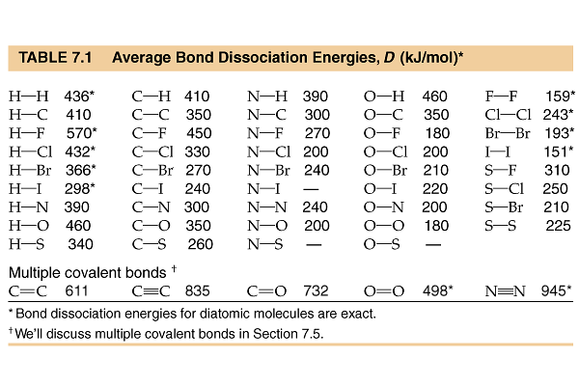

Heats of formation

compound | ΔHº_{f} (kJ/mol)
CO₂(g) | -393.5
H₂O(l) | -285.8
H₂O(g) | -241.8
C₆H₁₂O₆(s) | -1274.4

